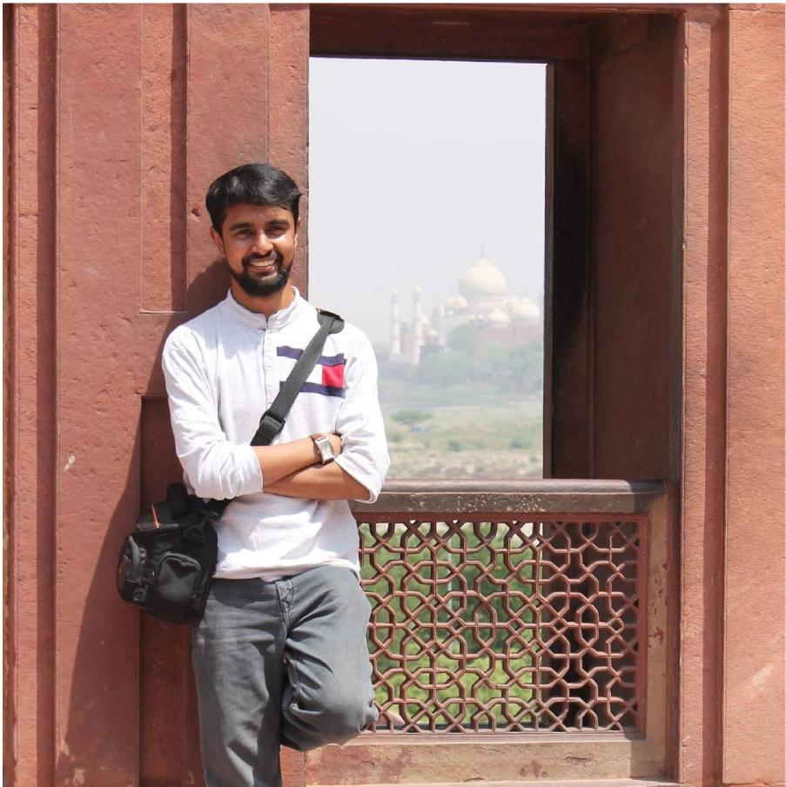 | Abaan Ahmed Momin  is from St. Xavier's College,  Mumbai. He studied  Astronomy and Creative  Writing at St. Catz in the  Trinity Term, 2013. He has,  since then, completed his  Masters in Geology from IIT  Bombay and he is currently  working in Cairn India, an oil  and gas company in Delhi.

